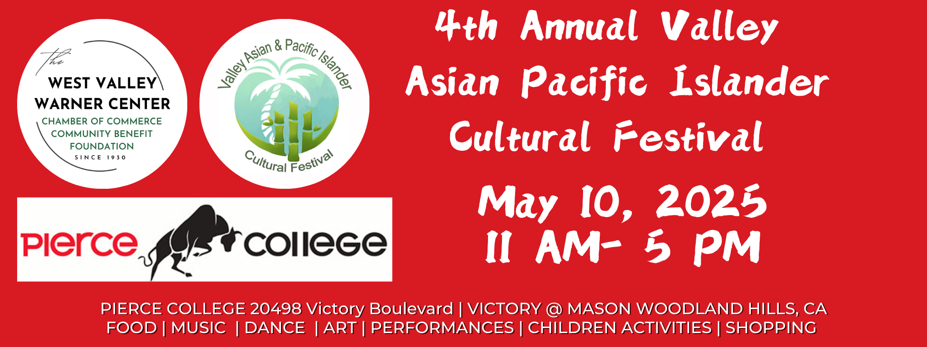
FOR IMMEDIATE RELEASE
Valley Asian & Pacific Islander Cultural Festival established by prominent West San Fernando Valley Organization-West Valley~Warner Center Chamber of Commerce Community Benefit Foundation.
Woodland Hills, CA
The West Valley~Warner Center Chamber of Commerce announces the 4th Annual Valley Asian & Pacific Islander Cultural Festival taking place on May 10th 2025 at Pierce College in Woodland Hills “It just gets better and better every year. !!”. -Diana Williams Chamber of Commerce CEO and Executive Director of the Community Benefit Foundation
The West Valley~Warner Center Chamber of Commerce Community Benefit Foundation Valley Asian & Pacific Islander Cultural Festival is now an Annual Signature Event. Start Asian American Pacific Islanders Month by celebrating the vast diversity of Asian Cultures that enhances the San Fernando Valley and the City of Los Angeles. Attendees discover Asia as they enter the event, encouraging engagement across all diverse communities.
The event highlights the cultures of prominent cultures in Asia while showcasing the Asian-Owned Businesses in our West San Fernando Valley.
This bright and colorful one-day festival will provide over 50 cultural experiences to thousands of attendees. The cultural expression is delivered through dance and musical performances and arts, crafts , fashion and food demonstrations. Pop up markets offering Shopping and dining add to the festivities. Los Angeles personalities and talents will be celebrated and announced over the next several months.
Sponsors have been engaged to raise the experience of each culture to be an authentic and delightful visit for the guests, providing their cultural knowledge and access to an array of ideas, talent, and resources.
The planning committee has determined the time and location to be Pierce College in Woodland Hills on May 10, 2025 for the hours of 11 AM- 5PM. The West Valley~Warner Center Chamber of Commerce Community Benefit Foundation has participation from many community organizations.
Additional Festival highlights include:
- Experience breathtaking regional displays.
- Vote in the contest for the anchor sponsor for the “Most Beautiful Cultural Décor Award.”
- Shop with exhibitors. (Books, merchandise and souvenirs)
- Enter to win raffle giveaways and play children’s activities.
- Taste the regional foods of Asia with local vendors.
For up-to-date scheduling, performances, exhibits, food and more check out our social media platforms and websites.
Twitter: https://twitter.com/valleyasianfest Instagram: https://www.instagram.com/valleyasianfestival/
Facebook: https://www.facebook.com/wvwcchambervacf
Scan Code to enter website. 2024 Images Click Here.


